**Session report 25/11/2022:**

*LABAUVIE – RAFFAELLI EVA*

*ROB3*

The goal of today’s session is to continue the learning of the Jetson nano card, and try to get started with the camera AI function.

I directly went to the “Jetson AI fundamentals – Hello camera” on the Nvidia online courses about the jetson nano.

I listened to the online courses and plugged the card as indicated.

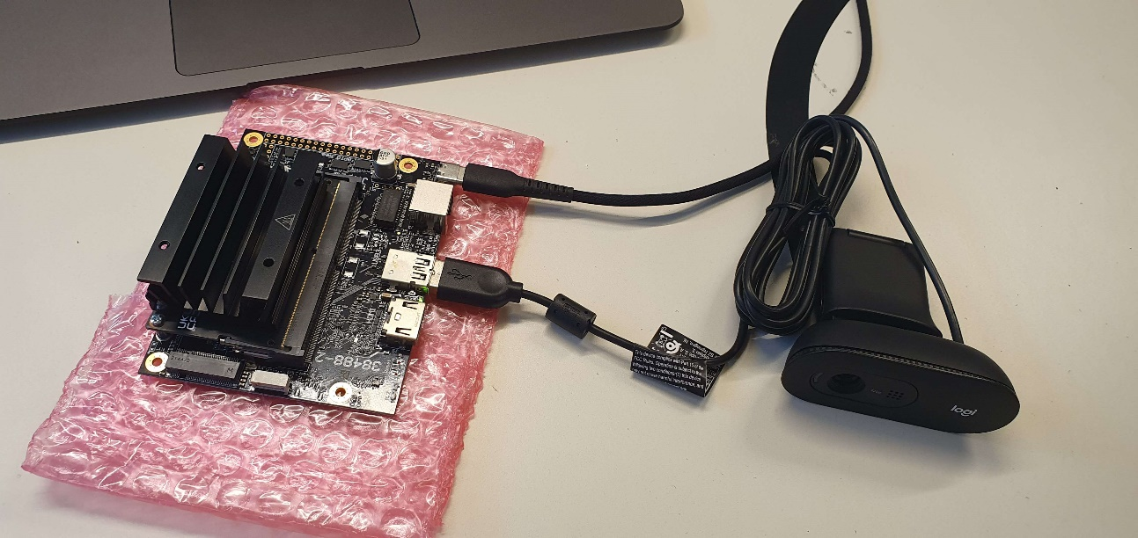

Since we need a linux terminal, they recommend using Windows Powershell for a window device. I logged into the card via the ssh command and the PowerShell.



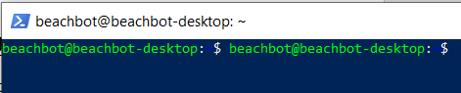

Next, I created a directory for the data.



And now I need to download the Docker container and run it.

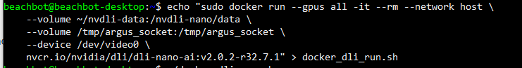

Then I typed :

**# make the script executable**

**chmod +x docker_dli_run.sh**

**# run the script**

**./docker_dli_run.sh**

But I have errors after executing the script, I’m trying to find solution to continue. 

I found what were the errors:

The nvidia card wasn’t connected to internet so I had to connect it with a cable to a phone in mobile hotspot mode. It finally ended up downloading the files.

